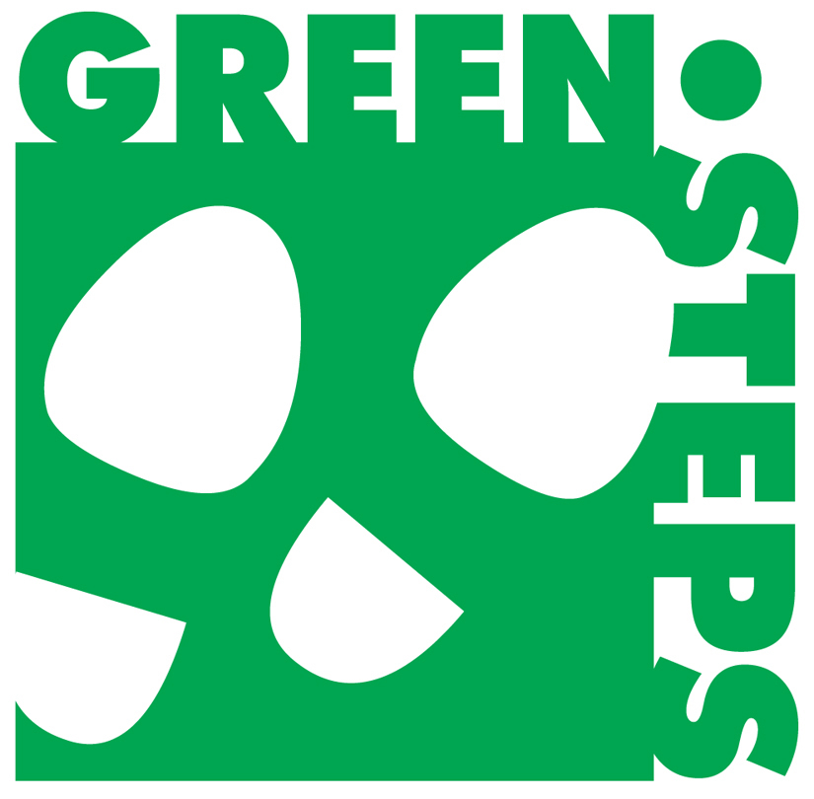
GREEN STEPS CONSERVE EVALUATION FORM
for Reduce, Reuse, Recycle, Green Purchasing Projects
Submit by May 1 to jane.hiller@sonoco.com

County: School Name:

Administrator Name and Email:

School Faculty/Staff Contacts for Green Steps Projects (minimum two)
Name: Email Address:

Please indicate with an “X” which of the following CONSERVE projects have been model quality for at least 12 months and are worthy of an award. Please describe the projects in more detail under "Notes" including the number of students participating in each project

CONSERVE: REDUCE
Share Table___ Tap & Stack___ Commercial Compost___

Other(s):
Notes:

CONSERVE: REUSE
Upcycled STEAM projects___ Upcycled Planters___ Orange Peel Classroom Cleaner___

Other(s):

Notes:

CONSERVE: RECYCLE
On-Site recycling___ Off-Site recycling___ Mail-In recycling___

Other(s):

Notes:

CONSERVE: GREEN PURCHASING
Students Making and Selling Items___ Students Growing and Selling Items___

Other(s):

Notes:

CONSERVE: ENERGY
Energy Audit and Act___

Other(s):

Notes:

*Respond with a “Y” or “N” for statements below
___ I met with this school team at least twice to plan and evaluate the projects
___ These projects incorporated the “Learn, Do, Teach” model of the SC Green Step
Schools program
___ These projects have been model quality (good examples for other schools) for at least 12 months
___ An appropriate video or pictures with detailed captions have been sent to both me and
jane.hiller@sonoco.com
___ I would like to nominate this school as the SC CONSERVE School of the Year

Mentor Name: Date:

Mentor Email Address:

